Position Available

Laborer I

Boston Harb

Boston Harbor Islands

JOB OVERVIEW:
Help keep the park clean, green, and beautiful! The Park Operations Crew assists with grounds maintenance and prepares for park programs including concerts, festivals, and conferences.

RESPONSIBILITIES:
The basic role of the Boston Harbor Islands Laborer is to perform the activities involved in the maintenance of state-operated park recreational areas and facilities. This work includes but is not limited to:
- Performing manual labor related to keeping the parks grounds neat and clean.
- Performing tasks related to grounds maintenance including running lawn mowers, line trimmers, brush saws and hedge trimmers. Mows and trims lawn areas around walkways. Tills, plants, weeds, and waters flower and shrub beds.
- Performs duties to assist in the upkeep of the parks infrastructure and buildings including sweeping, mopping, and painting.
- Assists with the set-up and break down of large-scale public programs including concerts, festivals, and conferences.
- Performs duties with the safety of the individual, fellow employees, and the public in mind. Comes to work properly dressed, uses proper PPE’s such as hearing/eye protection, vests, etc.
- Performs related duties as assigned.

QUALIFICATIONS:
Applicants must be at least 18 years old, safety conscious and familiar with materials and equipment used in park maintenance. Current and valid Massachusetts driver’s license.

LOCATION:
The Massachusetts Department of Conservation and Recreation is a major steward of the commonwealth’s natural and cultural resources. The Boston Harbor Islands National and State Park is a unique partnership park with an abundance of natural and cultural resources that offer tremendous recreational and educational opportunities. DCR owns 16.5 of the 34 islands and peninsulas in the park and staff the islands that are accessible by public ferry and recreational vessels during the season. More information about the park can be found at www.bostonharborislands.org

EMPLOYMENT INFORMATION:
Positions are available from early May through October and mid-June through September. The reporting location is Hingham, MA but the position will be primarily at an island location; boat transportation is provided. Laborers work a forty-hour week which could include nights, weekends, and holidays. Long term pay rate is $1287.80 bi-weekly. Uniforms and basic training are provided, park housing is not. Benefits may be available for long-term positions.

TO APPLY:
For April/May job opportunities please visit “Find Your Future Commonwealth Job”
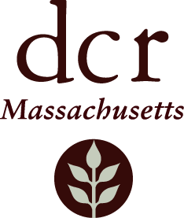
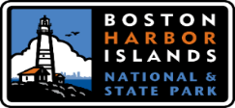
https://www.mass.gov/find-your-future-commonwealth-job . Under the “What Would You Like To Do?” section click on “Start Your Career-Find a Commonwealth Job” . On the MassCareers Job Opportunities page click on “Job Search” and in the Keyword section type “Boston Harbor Island”. For June opportunities please send your resume and cover letter to Sean McLaughlin at sean.mclaughlin@mass.gov

DCR is an Affirmative Action/Equal Opportunity Employer

