Boston Harbor Islands
Position Available
Forest and Park Supervisor I

JOB OVERVIEW:
Pack your overnight gear and oversee the island experience for our campers in this introductory supervisory position. Spend time in the great outdoors, interact with day and overnight visitors, groom trails, manage volunteer projects all in one of the coolest parks in Massachusetts!

RESPONSIBILITIES:
The basic role of the Boston Harbor Islands Forest and Park Supervisor I is to supervise the activities involved in the maintenance of state-operated parks. This work includes but is not limited to:
- The maintenance of an assigned recreational area including grounds maintenance, equipment maintenance, trail work, and campsite upkeep.
- Patrol recreational areas, facilities, and campgrounds to ensure compliance with applicable rules and regulations.
- Coordinate and supervise the activities and work of volunteers, stewardship groups, and park partners.
- Manage an island campground including checking-in campers, managing walk-ins, providing site assignments, as well as general upkeep of sites including minor trash removal and groundskeeping.
- Provide exceptional visitor services including answering questions and providing island orientation to increase the enjoyment of park resources.
- Performs related duties as assigned.

QUALIFICATIONS:
Applicants must be at least eighteen years old, safety conscious and familiar with materials and equipment used in park maintenance. Current valid driver’s license required.

LOCATION:
The Massachusetts Department of Conservation and Recreation is a major steward of the commonwealth’s natural and cultural resources. The Boston Harbor Islands National and State Park is a unique partnership park with an abundance of natural and cultural resources that offer tremendous recreational and educational opportunities. DCR owns 16.5 of the 34 islands and peninsulas in the park and staff the islands that are accessible by public ferry and recreational vessels during the season. More information about the park can be found at www.bostonharborislands.org

EMPLOYMENT INFORMATION:
Positions are available from early April/May through mid-October with additional positions available from mid-June through early September. The reporting location is Hingham, MA but the position may require an overnight commitment at an island location (boat transportation is provided). On-island housing ranges from dormitory to camping style living with limited utilities. May-Oct pay rate is $1435.37 bi-weekly. Uniforms, basic training, and park housing is provided. Benefits may be available for long-term positions.

TO APPLY:
For April/May job opportunities please visit “Find Your Future Commonwealth Job”
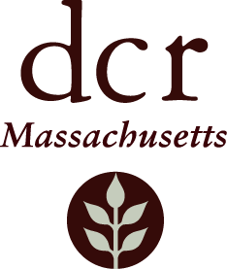
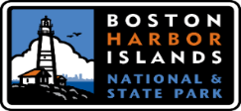
https://www.mass.gov/find-your-future-commonwealth-job . Under the “What Would You Like To Do?” section click on “Start Your Career-Find a Commonwealth Job” . On the MassCareers Job Opportunities page click on “Job Search” and in the Keyword section type “Boston Harbor Island”. For June opportunities please send your resume and cover letter to Sean McLaughlin at sean.mclaughlin@mass.gov

______________________________________________________________________________ ___________________________________
DCR is an Affirmative Action/Equal Opportunity Employer

